**Please complete and return .pdf copy to glister0427@gmail.com
by December 23rd, 2012**

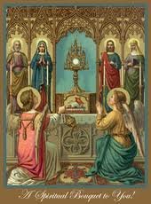

In thanksgiving for his support of the reverent celebration of the Holy Mass
A Spiritual Bouquet for Bishop Robert C. Morlino

☐ Holy Mass

☐ Rosary

☐ Eucharistic Adoration

☐ Chaplet of Divine Mercy

☐ Stations of the Cross

☐ Other Devotion or Personal Sacrifice ( )

Offered by: __________________________________________________________________________________
(Name and Parish)

Personal note:

